**CCT College Dublin**

**Assessment Cover Page**

|  |  |
| --- | --- |
| **Module Title:** | Web Development |
| **Assessment Title:** | Data Manipulation and Validation |
| **Lecturer Name:** | Mikhail Timofeev |
| **Student Full Name:** | Halil UGUR |
| **Student Number:** | 2022389 |
| **Assessment Due Date:** | 04/12/2022 @23:59 |
| **Date of Submission:** | 03.12.2022 |

**Declaration**

|  |
| --- |
| By submitting this assessment, I confirm that I have read the CCT policy on Academic Misconduct and understand the implications of submitting work that is not my own or does not appropriately reference material taken from a third party or other source. I declare it to be my own work and that all material from third parties has been appropriately referenced. I further confirm that this work has not previously been submitted for assessment by myself or someone else in CCT College Dublin or any other higher education institution. |

Contents

Abstract 3

Introduction 4

.gitignore File 5

Bootstrap 6

Page Sub-Parts 6

Green Buttons 6

SQL Result Screens 7

Limited SQL Queries 7

Data SQL field 8

Extra 8

GitHub Repository 9

References 9

# Abstract

This project is to perform Data Definition Language (DDL) and DML (Data Manipulation Language) operations on the employees database using the SQL.js library. It has been developed as user-friendly by using bootstrap, codemirror and code-prettify in the design of the interface. The project has been developed in 3 parts and the results are given with the visuals.

# Introduction

Our project has 4 pages. First one is home page and we have been explained what this project is. Other 3 pages have been working on the employee’s database. Part 1, 2 and 3 pages were developed using bootstrap to provide detailed information to the user.

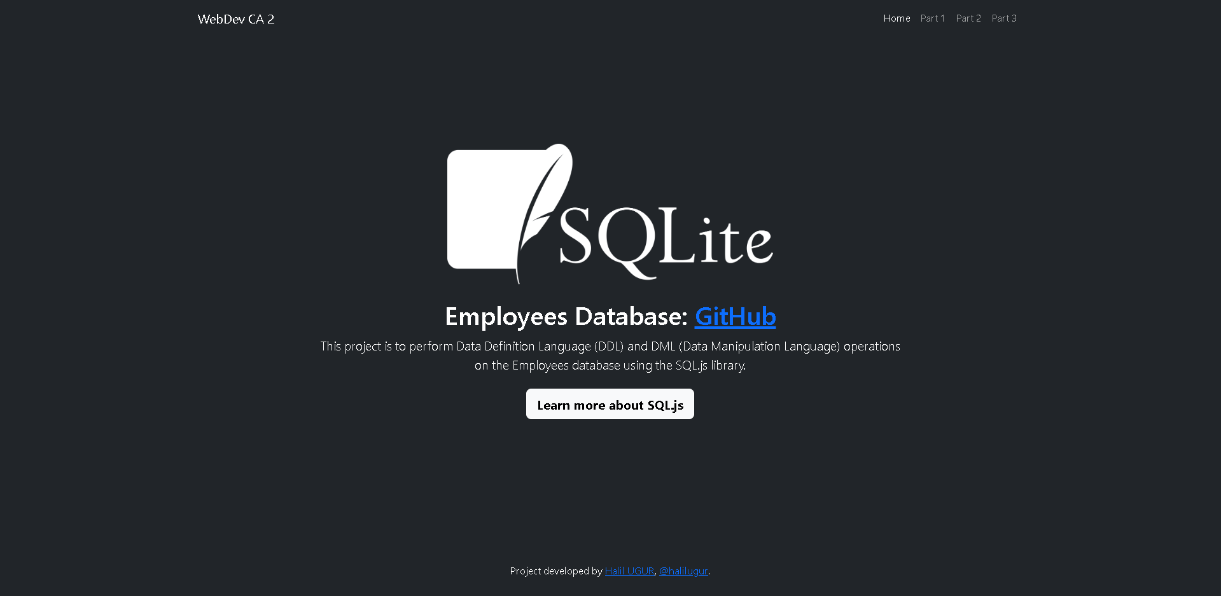

Picture : Home page screen

This page as a cover that explained project. This page has structure that navbar, content and footer sections. Also, part pages allow us to see the SQL outputs instantly by writing the answers to the questions asked in the database project here. Since the employee’s database is a large database, we need to set limits on each query. That's why we put a bar on each section page where we can increase the limit from 1 to 1000. Thus, the user will be able to dynamically select the desired range.

Picture : Part 1 page screen

Picture : Part 2 page screen

Picture : Part 3 page screen

# .gitignore File

Git is a tool that helps us save different versions of files. We can make sure certain files don't get saved by using a ".gitignore" file. This will keep private files like passwords, large file, and API keys safe, and keep our git from getting cluttered. It's not a good idea to put the employee’s database in the git repository because it is too big.

Picture : .gitignore file content

# Bootstrap

Bootstrap is a tool that helps web developers build websites faster by providing them with templates and commands. It is made up of HTML, CSS, and JavaScript, and makes it easier to design websites that look great on any device. In this project, we developed our interface using bootstrap.

# Page Sub-Parts

Each page has sections where the user can execute queries. Also, Part 1 page is bolded.

Picture : Queries screen

# Green Buttons

Picture : Execute has been changed to a green button.

# SQL Result Screens

Picture : Page 1 example result

Picture : Part 2 example result

Picture : Page 3 example result

# Limited SQL Queries

Picture : Query limitation screen

# Data SQL field

HTML Escape Characters are used in queries.

# Extra

When you go over the Run buttons, there is an English equivalent of the expression that SQL data wants to run.

# GitHub Repository

All the materials we use can be accessed from this repo: [GitHub Repo](https://github.com/halilugur/webdev_ca2)

# References

1. <https://github.com/googlearchive/code-prettify>
2. <https://codemirror.net/>
3. <https://getbootstrap.com/>
4. <https://www.geeksforgeeks.org/bootstrap/>
5. <https://www.w3schools.com/bootstrap/bootstrap_ver.asp>
6. <https://sql.js.org/#/>
7. <https://sql.js.org/examples/GUI/>
8. <https://stackoverflow.com/>